

**B.P.H.E.SOCIETY’S**

**INSTITUTE OF MANAGEMENT STUDIES**

**(CAREER DEVELOPMENT AND RESEARCH)**

**A**

**PROJECT REPORT**

ON

**“ ONLINE MATRIMONIAL SYSTEM** **”**

**FOR**

**IDEAL ART SOFTWARE**

**AHMEDNAGAR**

By

MISS. SAKHARE MRUNAL

In Partial Fulfillment Of

**Master of Computer Application (MCA)**

**SAVITRIBAI PHULE UNIVERSITY OF PUNE**

**Institute of Management Studies Career Development and Research,**

**Station Road, Ahmednagar – 414001**

**2017-18**

**ACKNOWLEDGEMENT**

The successful realization of the project is an outgrowth of a consolidated effort of people from disparate fronts.

I express my deep thanks to Prof .U. H. Nagarkar (HOD IT, IMSCDR) and Dr. M. B. Mehta (Director, IMSCDR) for warm hospitality and affection extended towards me, Their constant encouragement has helped to widen the horizon of my knowledge and inculcate the spirit of dedication to the purpose

I am thankful to Prof. --------------- ( Project Guide) and lab/ staff for their valuable advice and support extended to me without which I would not have been able to complete my project,

For a success, it requires diligence, perseverance, inspiration, motivation and innovation. Words cannot express my gratitude for all those people who helped me directly or indirectly in my endeavor.

I take this opportunity to express my sincere thanks to all the staff members of the IMS-IT department for their valuable suggestions

**MRUNAL SAKHARE**

INDEX

|  |  |
| --- | --- |
| **Chapter** | **Description** |
| 1 | **Introduction**  1.1 Company Profile  1.2 Existing System & Need for the System  1.3 Scope of Work  1.4 Operating Environment  1.5 Detail Description of Technology Used |
| 2 | **Proposed System**  2.1 Proposed System  2.2 Objective of System  2.3 User Requirements |
| 3 | **Analysis and Design**  3.1 Use Case Diagrams  3.2 Activity Diagrams  3.3 Sequence Diagram  3.4 Collaboration Diagram  3.5 Class Diagram  3.6Component Diagram  3.7Table Design  3.8 User Interface Screenshots  3.9 Test Procedures & Implementation |
| 4 | **User Manual** |
| 5 | **Drawbacks & Limitations** |
| 6 | **Proposed Enhancements** |
| 7 | **Conclusion** |
| 8 | **Bibliography** |

**Chapter1**

**INTRODUCTION**

**INTRODUCTION:**

Online Matrimonial System provide platform to a lot of Bride/Groom for finding perfect match. The drawback of existing system is that searching a good life partner in this world is the times Consuming and cost effective. Online matrimonial system is used to overcome these drawbacks. This Secured Online Matrimonial System is a useful for a person of any religion who wishes to find a suitable life partner for himself or her Matrimonial

Web Application will allow a new user to register and after successfully registration user can get email confirmation, after completing registration users profile will be visible to other users. Bride/Groom can directly search Partner according to their required criteria.

Due to computerized and it is available online, people can register as and when they require and they can register wherever they are, so it provides lot of flexibility for people to search their companions easily.

Today, the marriage alliance arranged by known people and that are conducted manually and the amount of time required is very huge. Only they can help to know only few alliances.

* 1. Existing System and Need of the System:

The existing system was an automated system but It was found to be inefficient in meeting the growing demands of population and different online matrimonial take a lot of time and money for searching a suitable match. But still they are not able to provide a good life partner

2.1. Drawbacks in the existing system

1. The existing system is not user-friendly system.
2. Time Consuming to search a Perfect Match.
3. Lack of security.
4. The existing system does not implement restriction for users to access the data.

Secured online matrimonial system is designed to overcome the drawbacks of existing system. It also provides fast searching for a life partner and sending his/her contact or communicates with the existing members. As both the members will agree they meet together for the marriage. A person can search for a bride or a groom of any religion of any caste.

* 1. Scope Of Work:

Scope of this project is very board in terms of manually taking registration.

Some points to be noted are:

* Real time test can be conducted with security .
* Search can be generated very quickly.
* Admin can be able to add, update ,delete news from the site.
* Admin can be able to add and remove photos from the site.
* Admin can the manage user and their information .
* Admin can download and print necessary information

**1.4. Operating Environment –Hardware and Software:**

**1.4.1. OPERATING SYSTEMS**

An **operating system** (**OS**) is [software](http://en.wikipedia.org/wiki/Software), consisting of [programs](http://en.wikipedia.org/wiki/Computer_program) and [data](http://en.wikipedia.org/wiki/Data), that runs on [computers](http://en.wikipedia.org/wiki/Computer) and manages computer hardware resources and provide common services for efficient execution of various [application software](http://en.wikipedia.org/wiki/Application_software).

For hardware functions such as input and output and [memory allocation](http://en.wikipedia.org/wiki/Dynamic_memory_allocation), the operating system acts as an intermediary between application programs and the computer hardware, although the application code is usually executed directly by the hardware and will frequently call the OS or be interrupted by it. Operating systems are found on almost any device that contains a computer from [cellular phones](http://en.wikipedia.org/wiki/Cellular_phone) and [video game consoles](http://en.wikipedia.org/wiki/Video_game_console) to [supercomputers](http://en.wikipedia.org/wiki/Supercomputers) and [web servers](http://en.wikipedia.org/wiki/Web_servers).

**Examples**: Some of popular modern operating systems for personal computers are [Linux](http://en.wikipedia.org/wiki/GNU/Linux)/GNU, [Mac OS](http://en.wikipedia.org/wiki/Mac_OS_X) X, [and Microsoft Windows](http://en.wikipedia.org/wiki/Microsoft_Windows).

The selection of hardware is very important in the existence and proper working of any software. When selecting hardware, the size and requirements are also important.

**1.4.2. Software Requirements:**

Operating system : Windows XP or any latest version of windows

Web Browser : Mozilla Firefox or any browser

Front- End : PHP,HTML

Back- End : MySQL

Server : xampp-win32-1.7.2 Server

Project will be done in PHP as front end and MySQL as back end.

**1.4.3. Hardware Requirements:**

Processor : INTEL Pentium 4

RAM : 1 GB

Hard Disk Drive : 80 GB

* Keyboard
* Mouse
* Color Monitor
* Printer (Optional)
* U.P.S

**Server side**

* Minimum P-IV machine
* 2GB RAM
* 320GB Hard Disk
* Keyboard, Mouse
* Color monitor

**1.5 Detail Description of Technology Used**

**1.5.1. PHP:**

Since the Internet is packed with millions of acronyms, PHP is another one! PHP stands for PHP: Hypertext Preprocessor. Yes, the acronym is recursive and for the purposes of this class, we will just call it “PHP.”

PHP is a server-side scripting language and is very similar to C, Java, and Perl. PHP allows the Programmer to dynamically generate content, instead of statically like regular ‘ol’ HTML. This tutorial will cover uses of PHP from simple data processing of forms to parsing a page for relevant information.

**Embedding PHP into HTML includes:**

1) Quicker response time

2) Improved security

3) Transparency to the end user

* PHP language syntax is borrowed from C with elements of Perl, C++ and Java.
* PHP is also integrates easily with MySQL which is a free non-proprietary database. MySQL can be used to create large powerful databases and because it is free is often favored by non-profit organizations.

**The following are some advantages of using someone else’s Web environment:**

* **It’s easier than setting up your own:** You just copy your Web pages onto the other party’s computer, and that’s it. You don’t need to install any software or hardware or resolve any computer problems. Someone else handles that for you.
* **Less technical skill is required:** You need to understand only Web languages, such as HTML and PHP. You don’t need to know about Internet connections, Web servers, computer administration, and other technical things. Some people are very interested in these things, but some are not.

**PHP has many features designed specifically for use in Web sites, including the following:**

* **Interact with HTML forms:** PHP can display an HTML form and process the information that the user types in.
* **Communicate with databases:** PHP can interact with databases to store information from the user or retrieve information that is displayed to the user.
* **Generate secure Web pages:** PHP allows the developer to create secure Web pages that require users to enter a valid username and password before seeing the Web page content.

PHP features make these and many other Web page tasks easy. PHP is only server-side, meaning it can’t interact directly with the user’s computer. That means PHP can’t initiate actions based on the status of the user’s computer, such as mouse actions or screen size. Therefore, PHP alone can’t produce some popular effects, such as navigation menus that drop down or change color. On the other hand, JavaScript, a client-side scripting language, can’t access the server, limiting its possibilities. For example, you can’t use JavaScript to store data on the server or retrieve data from the server. But wait! You don’t have to choose. You can use JavaScript and PHP together to produce Web pages that neither can produce alone. See Chapter 11 for details on using JavaScript and PHP together.

**1.5.2. HTML:**

HTML, which stands for Hypertext Markup Language, is the predominant markup language for web pages. HTML is the basic building-blocks of webpage.

HTML is written in the form of HTML elements consisting of tags, enclosed in angle brackets (like <html>), within the web page content. HTML tags normally come in pairs like <h1> and </h1>. The first tag in a pair is the start tag, the second tag is the end tag (they are also called opening tags and closing tags).

The purpose of a web browser is to read HTML documents and compose them into visual or audible web pages. The browser does not display the HTML tags, but uses the tags to interpret the content of the page.

HTML elements form the building blocks of all websites. HTML allows images and objects to be embedded and can be used to create interactive forms. It provides a means to create structured documents by denoting structural semantics for text such as headings, paragraphs, lists, links, quotes and other items. It can embed scripts in languages such as JavaScript which affect the behavior of HTML WebPages.

Web browsers can also refer to Cascading Style Sheets (CSS) to define the appearance and layout of text and other material. The W3C, maintainer of both the HTML and the CSS standards, encourages the use of CSS over explicitly presentational HTML markup.

**Chapter 2**

**PROPOSED SYSTEM**

**2.1** **Proposed System:**

Secured online matrimonial system is designed to overcome the drawbacks of existing system. It also provides fast searching for a life partner and sending his/her contact or communicates with the existing members. As both the members will agree they meet together for the marriage. A person can search for a bride or a groom of any religion of any caste.

The **ONLINE MATRIMONIAL SYSTEM**  is growing as the internet emerges as the best Technology which provides a fast and efficient access to any information about anything. Difficulty in Keeping the details of each user and their partners, delay in sending messages to them and spending so much money for finding a good life partner causes the appearance of this website. The Project concentrates on to surmount these difficulties.

**Scope:**

1. A Marriage Bureau system is designed for finding appropriate and suitable matches.
2. Applicants with age above 21 for male and 18 for female apply with their complete bio data.
3. Based on the bio data and requirements of the applicants and matching maximum number of attributes against both, the desired match is found.

1. Bio data includes Name, Caste, Age, Height, Qualifications, Occupation, and Income that are considered principle aspects for finding matches.

**2.2. Purpose /Objective:**

A Marriage Bureau system is designed for finding appropriate and suitable matches. Applicants with age above 21 for male and 18 for female apply with their complete bio data. Based on the bio data and requirements of the applicants and matching maximum number of attributes against both, the desired match is found. Biodata includes Name, Caste, Age, Height, Qualifications, Occupation, and Income that are considered principle aspects for finding matches.

**2.3 User Requirements**

**Requirement Determination techniques used** – Gathering relevant information for building a system is not an easy task. Therefore, there are different techniques to collect the data in an organized manner. We did it as follows:

* + - Analyzed existing system.
    - Interview the client as well as developers.
    - Tried to understand the manual process and its drawbacks.
    - Tried to identify the time wasting process in the manual system.

**2.3.1 FEASABILITY REPORT**

**2.3.1.1 ECONOMIC FEASIBILITY**

Economic analysis is most frequently used for evaluation of the effectiveness of the system. More commonly knows as cost/benefit analysis the procedure is to determine the benefit and saving that are expected from a system and compare them with costs, decisions is made to design and implement the system.

This part of feasibility study gives the top management the economic justification for the new system. This is an important input to the management the management, because very often the top management does not like to get confounded by the various technicalities that bound to be associated with a project of this kind. A simple economic analysis that gives the actual comparison of costs and benefits is much more meaningful in such cases.

In the system, the organization is most satisfied by economic feasibility. Because, if the organization implements this system, it need not require any additional hardware resources as well as it will be saving lot of time.

**2.3.1.2. TECHNICAL FEASIBILITY**

Technical feasibility centers on the existing manual system of the test management process and to what extent it can support the system. According to feasibility analysis procedure the technical feasibility of the system is analyzed and the technical requirements such as software facilities, procedure, inputs are identified. It is also one of the important phases of the system development activities.

The system offers greater levels of user friendliness combined with greater Processing speed. Therefore, the cost of maintenance can be reduced. Since, processing speed is very high and the work is reduced in the maintenance point of view management convince that the project is operationally feasible.

**2.3.2 Functional Requirements**

* Maintain Monitor by Administrator
* Approve Developer by Administrator
* Assign Monitor To Developer by Administrator
* Alerts notifications to Administrator
* Requirements Stamp (Approved by both client as well as Monitor)
* Understandings Stamp (Approved by both client as well as Monitor)
* Monitor Chat with Client as well as Developer but Client can’t chat with developer directly.
* Post new Project by paying 9$.
* Refund Payment to client if developer breaks seal.(Unable to complete project in estimated time)
* Monthly subscription to developers of 199$.

**Chapter 3**

**ANALYSIS & DESIGN**

Matrimonial UML Diagram :-

Use-case Diagram:

1.Admin use case Diagram 

2.User –use-case-Diagram



**1. Activity-Diagram:{User}**

1.Basic_Registration:



2.Registration:



3.Contact Us:



4.Feedback:



5.Search:



**Activity-Diagram:{Admin}**

**1.Login:**



2.State



3.District:



4.Tahsil:



5.Education:



6.Religion:



7.Cast:



8.Sub Cast:



9.Event:



10.Gallary:



11.Office Branch:



12.Sucess Story:



13.Feedback:



14.Contact:

15.Change Password:



Component Diagram

1.Sub cast Component



2.District Component



Class Diagram



**3.10 Table Specification**

1. admin:

| **Name** | **Type** | **Constraints** |
| --- | --- | --- |
| **aidPrimary** | int(11) | P.K. |
| **username** | varchar(200) |  |
| **password** | varchar(200) |  |

1. state

| **Name** | **Type** | **Constraints** |
| --- | --- | --- |
| **state_idPrimary** | int(11) | P.K. |
| **state_name** | varchar(100) |  |
| **flag** | varchar(10) |  |

1. district

| **Name** | **Type** | **Constraints** |
| --- | --- | --- |
| **district_idPrimary** | int(11) | P.K. |
| **state_id** | int(11) | F.K. |
| **district_name** | varchar(100) |  |
| **flag** | varchar(10) |  |

1. tehsil :

| **Name** | **Type** | **Constraints** |
| --- | --- | --- |
| **tehsil_idPrimary** | int(11) | P.K. |
| **district_id** | int(11) | F.K. |
| **tehsil_name** | varchar(100) |  |
| **flag** | varchar(10) |  |

1. education:

|  |  |  |
| --- | --- | --- |
| **Name** | **Type** | **Constraints** |
| **education_idPrimary** | int(11) | P.K. |
| **education_name** | varchar(200) |  |
| **flag** | varchar(10) |  |

1. religion:

| **Name** | **Type** | **Constraints** |
| --- | --- | --- |
| **religion_idPrimary** | int(11) | P.K. |
| **religion_name** | varchar(300) |  |
| **flag** | varchar(10) |  |

1. cast:

| **Name** | **Type** | **Constraints** |
| --- | --- | --- |
| **cast_idPrimary** | int(11) | P.K. |
| **religion_id** | int(11) | F.K. |
| **cast_name** | varchar(300) |  |
| **flag** | varchar(10) |  |

1. subcast:

| **Name** | **Type** | **Constraints** |
| --- | --- | --- |
| **subcast_idPrimary** | int(11) | P.K. |
| **cast_id** | int(11) | F.K. |
| **subcast_name** | varchar(300) |  |
| **flag** | varchar(10) |  |

1. event:

|  |  |  |
| --- | --- | --- |
| **Name** | **Type** | **Constraints** |
| **event_idPrimary** | int(11) | P.K. |
| **event_title** | varchar(300) |  |
| **event_date** | varchar(20) |  |
| **event_details** | varchar(500) |  |
| **flag** | varchar(10) |  |

1. gallery:

| **Name** | **Type** | **Constraints** |
| --- | --- | --- |
| **gid** | int(11) | P.K. |
| **gname** | varchar(500) |  |
| **gphoto** | varchar(200) |  |
| **flag** | varchar(10) |  |

1. branch:

| **Name** | **Type** | **Constraints** |
| --- | --- | --- |
| **branch_idPrimary** | int(11) | P.K. |
| **branch_name** | varchar(300) |  |
| **tehsil_id** | int(11) | F.K. |
| **contact_number** | varchar(20) |  |
| **email_id** | varchar(50) |  |
| **latitude** | varchar(30) |  |
| **longitude** | varchar(30) |  |
| **address** | varchar(500) |  |
| **flag** | varchar(10) |  |

1. success_story:

| **Name** | **Type** | **Constraints** |
| --- | --- | --- |
| **success_story_idPrimary** | int(11) | P.K. |
| **bride_groom_name** | varchar(300) |  |
| **bride_name** | varchar(200) |  |
| **marriage_photograph** | varchar(200) |  |
| **success_story** | text |  |
| **flag** | varchar(10) |  |

1. suggestion:

|  |  |  |
| --- | --- | --- |
| **Name** | **Type** | **Constraints** |
| **suggestion_idPrimary** | int(11) | P.K. |
| **user_name** | varchar(200) |  |
| **mobile_number** | varchar(15) |  |
| **email_id** | varchar(50) |  |
| **suggestion_message** | varchar(500) |  |
| **flag** | varchar(5) |  |

1. basic_registration:

| **#** | **Name** | **Type** | **Constraints** |
| --- | --- | --- | --- |
| 1 | **reg_idPrimary** | int(11) | P.K. |
| 2 | **first_name** | varchar(50) |  |
| 3 | **last_name** | varchar(50) |  |
| 4 | **mobile** | varchar(20) |  |
| 6 | **district** | int(50) | F.K. |
| 7 | **status** | varchar(50) |  |
| 8 | **email_id** | varchar(50) |  |
| 9 | **password** | varchar(30) |  |
| 10 | **profile_id** | int(11) | F.K. |
| 11 | **profile_status** | varchar(10) |  |
| 12 | **flag** | varchar(5) |  |

1. basic_registration:

Top of Form

| **Name** | **Type** | **Collation** |
| --- | --- | --- |
| **like_idPrimary** | int(11) | P.K. |
| **registration_id** | int(11) | F.K. |
| **profile_id** | int(11) | F.K. |
| **flag** | varchar(10) | latin1_swedish_ci |

Bottom of Form

1. registration:

|  |  |  |
| --- | --- | --- |
| **Name** | **Type** | **Constraints** |
| **registration_idPrimary** | int(11) | P.K. |
| **registration_date** | varchar(20) |  |
| **branch** | int(11) | F.K. |
| **type** | varchar(10) |  |
| **first_name** | varchar(50) |  |
| **middle_name** | varchar(50) |  |
| **surname** | varchar(50) |  |
| **mobile** | varchar(15) |  |
| **email_id** | varchar(50) |  |
| **current_address** | varchar(500) |  |
| **current_tehsil** | int(11) | F.K. |
| **education** | varchar(100) |  |
| **other_education** | varchar(100) |  |
| **occupation** | varchar(100) |  |
| **other_occupation** | varchar(100) |  |
| **annual_income** | varchar(20) |  |
| **subcast** | varchar(100) |  |
| **age** | int(11) |  |
| **status** | varchar(30) |  |
| **intercast** | varchar(10) |  |
| **blood_group** | varchar(5) |  |
| **complextion** | varchar(20) |  |
| **height** | varchar(20) |  |
| **weight** | varchar(10) |  |
| **birth_date** | varchar(15) |  |
| **birth_place** | varchar(50) |  |
| **diet** | varchar(20) |  |
| **personality** | varchar(30) |  |
| **disabilities** | varchar(20) |  |
| **disabilities_info** | varchar(200) |  |
| **spects** | varchar(5) |  |
| **hobby** | varchar(100) |  |
| **permanant_address** | varchar(200) |  |
| **permanant_tehsil** | int(11) | F.K. |
| **extra_info** | varchar(200) |  |
| **photo** | varchar(100) |  |
| **father** | varchar(10) |  |
| **father_name** | varchar(50) |  |
| **mother** | varchar(10) |  |
| **mother_name** | varchar(50) |  |
| **father_occupation** | varchar(200) |  |
| **mother_occupation** | varchar(200) |  |
| **total_brother** | varchar(5) |  |
| **total_sister** | varchar(5) |  |
| **married_brother** | varchar(5) |  |
| **married_sister** | varchar(5) |  |
| **contact_number** | varchar(15) |  |
| **postal_address** | varchar(500) |  |
| **native_address** | varchar(500) |  |
| **native_district** | int(11) | F.K. |
| **uncle_name** | varchar(200) |  |
| **uncle_address** | varchar(500) |  |
| **relatives** | varchar(500) |  |
| **other_information** | varchar(500) |  |
| **mangal** | varchar(20) |  |
| **rashi** | varchar(50) |  |
| **gan** | varchar(20) |  |
| **gotra** | varchar(30) |  |
| **nakshatra** | varchar(30) |  |
| **nadi** | varchar(20) |  |
| **charan** | varchar(20) |  |
| **dewak** | varchar(50) |  |
| **rasnaw** | varchar(50) |  |
| **exp_height** | varchar(20) |  |
| **age_difference** | varchar(10) |  |
| **exp_complextion** | varchar(20) |  |
| **marrital_status** | varchar(20) |  |
| **exp_mangal** | varchar(20) |  |
| **exp_horoscope** | varchar(20) |  |
| **exp_physical** | varchar(20) |  |
| **exp_disabilities** | varchar(200) |  |
| **exp_cast** | varchar(100) |  |
| **exp_education** | varchar(50) |  |
| **exp_occupation** | varchar(50) |  |
| **exp_other_occupation** | varchar(100) |  |
| **exp_annual_income** | varchar(20) |  |
| **exp_city** | varchar(50) |  |
| **exp_info** | varchar(200) |  |
| **flag** | varchar(10) |  |

**User Interface Screens:**

Homepage:

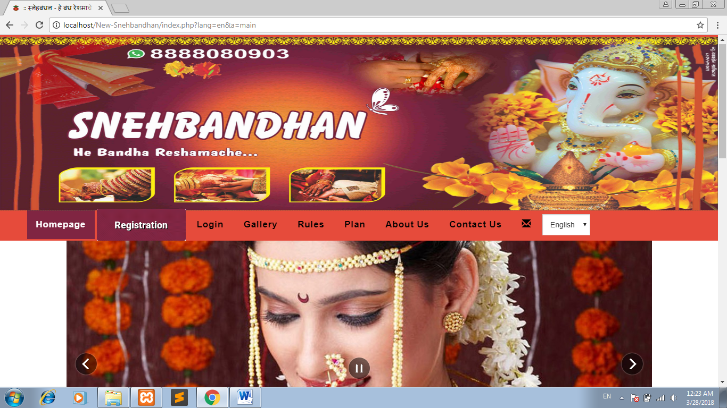

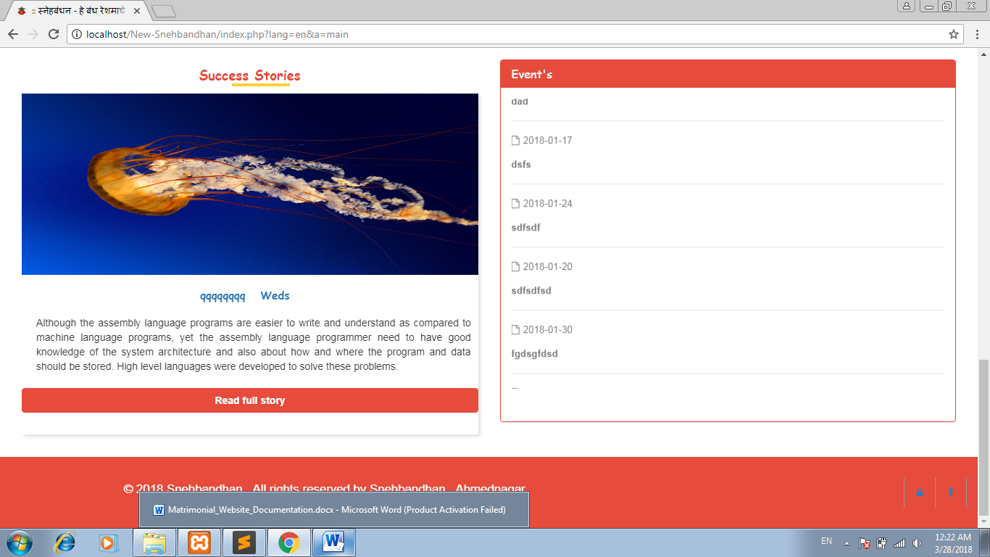

Gallery :

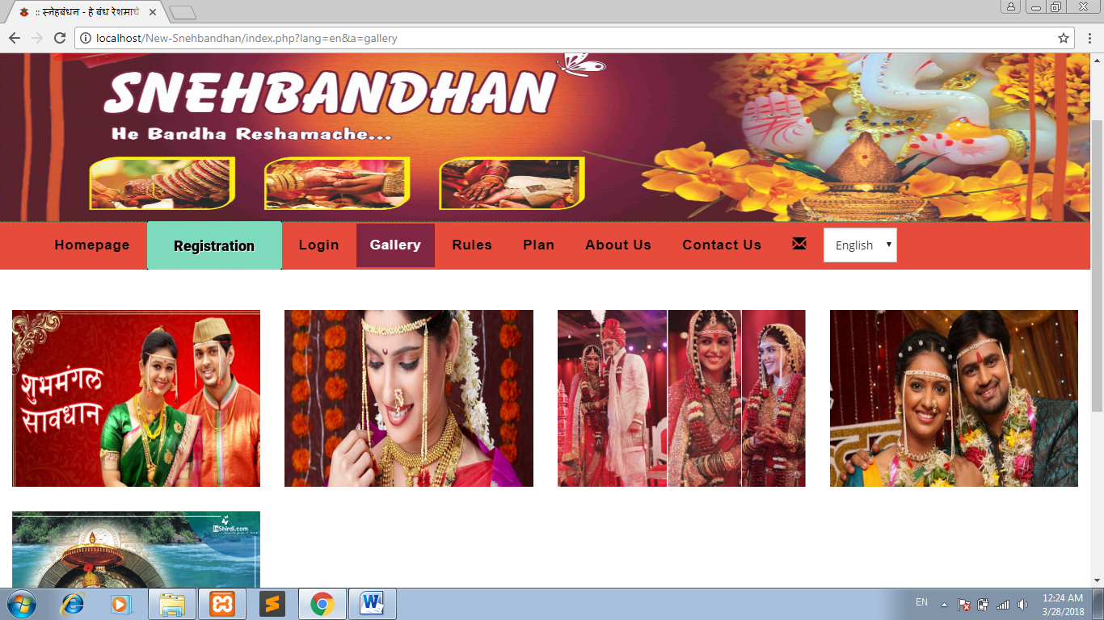

Rules:

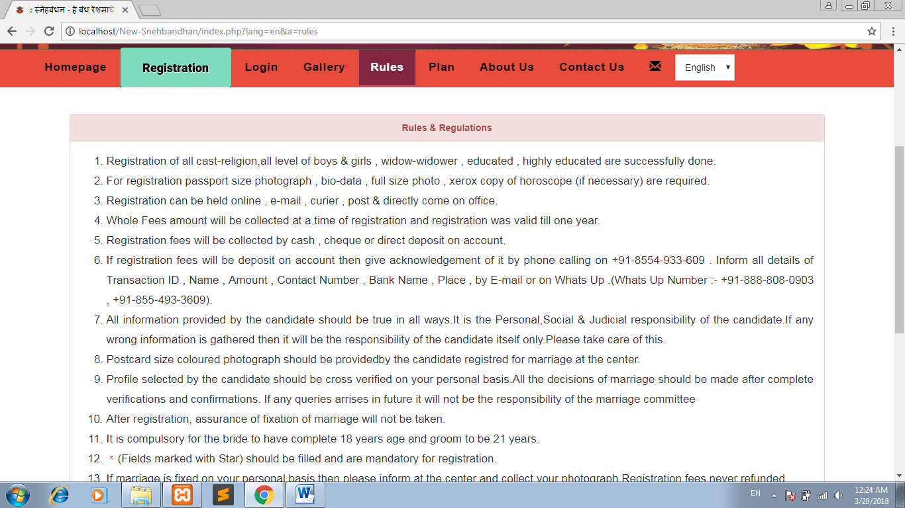

Plan

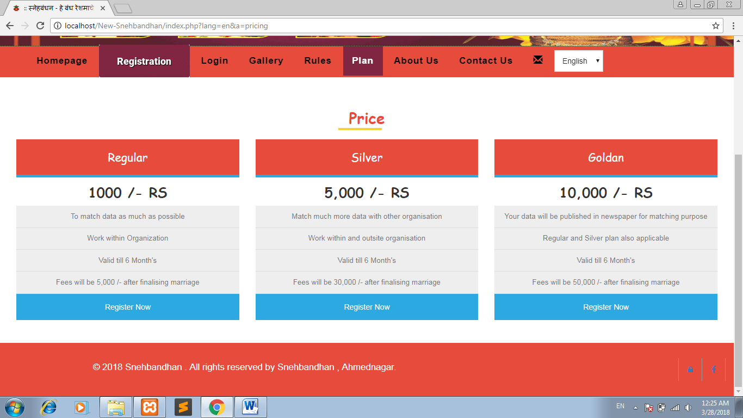

About Us

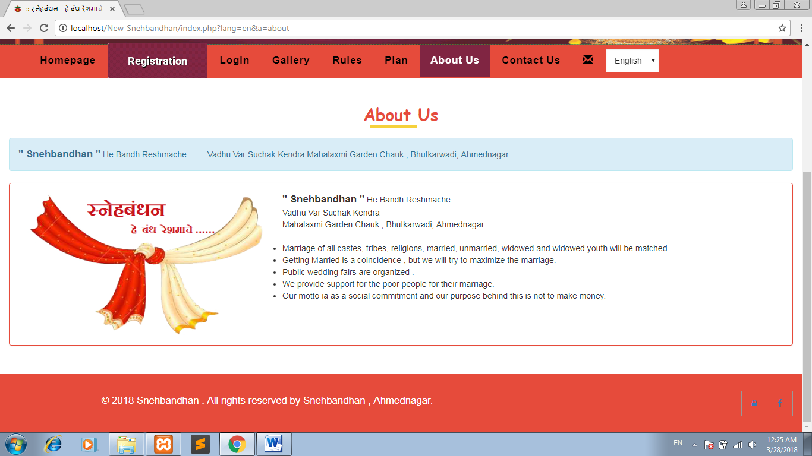

Contact Us :

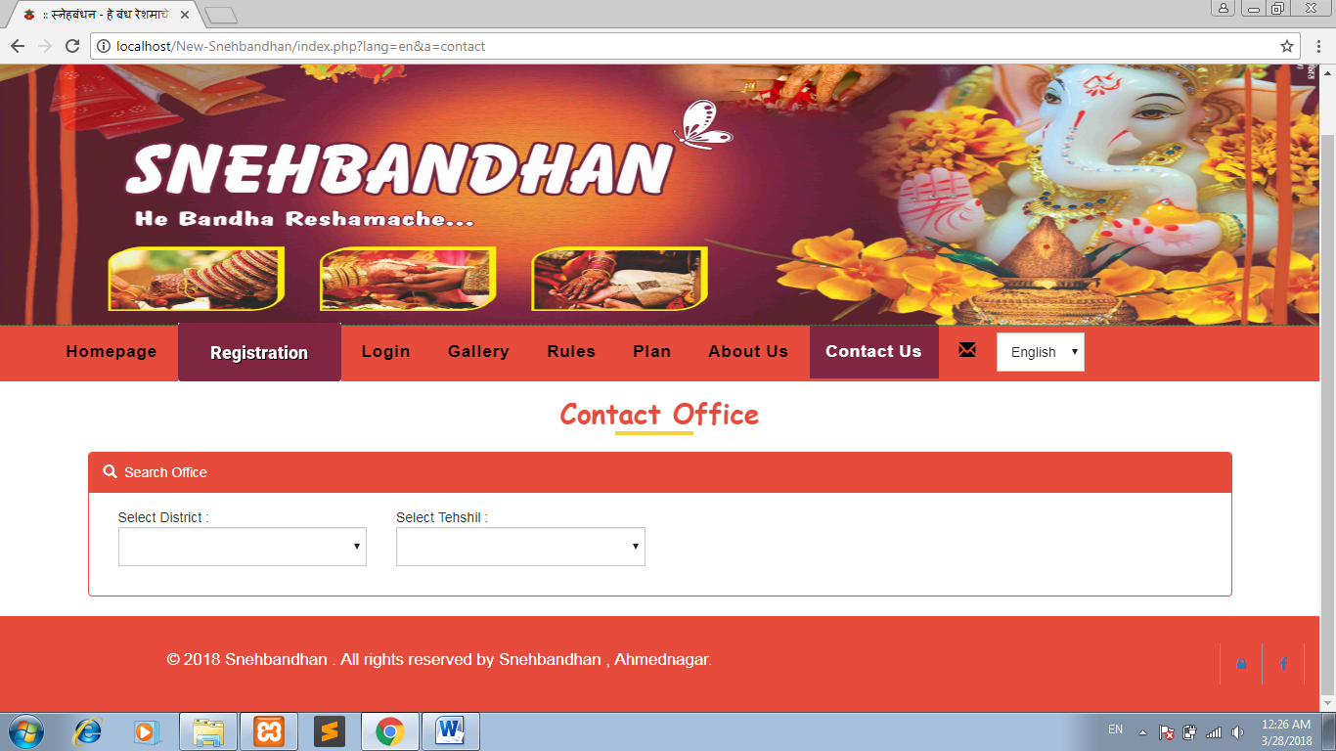

Basic Registration :

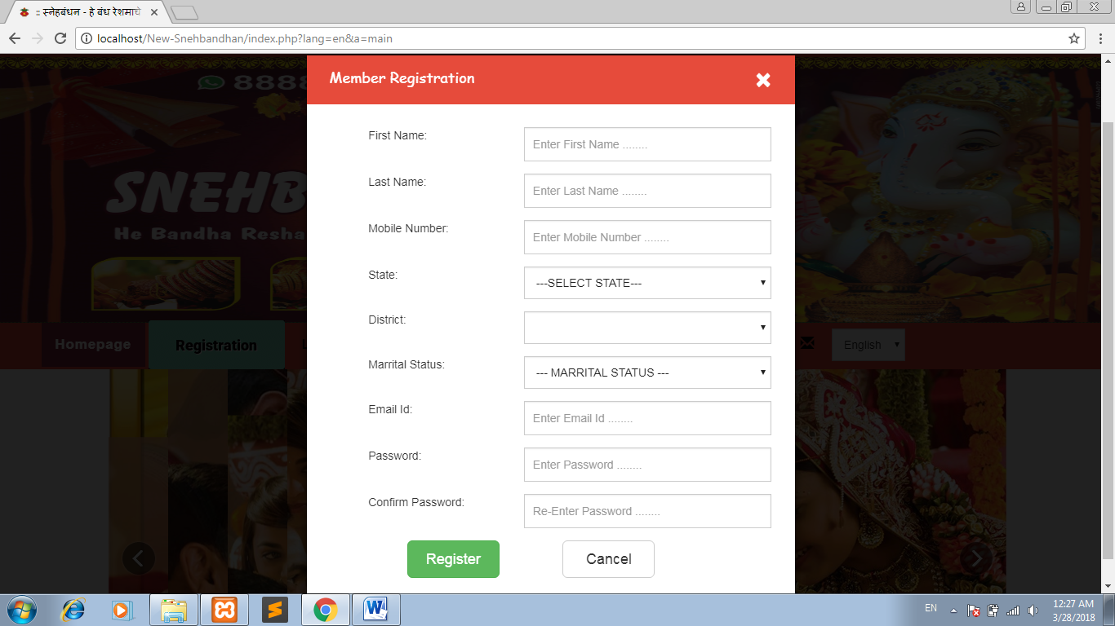

Login

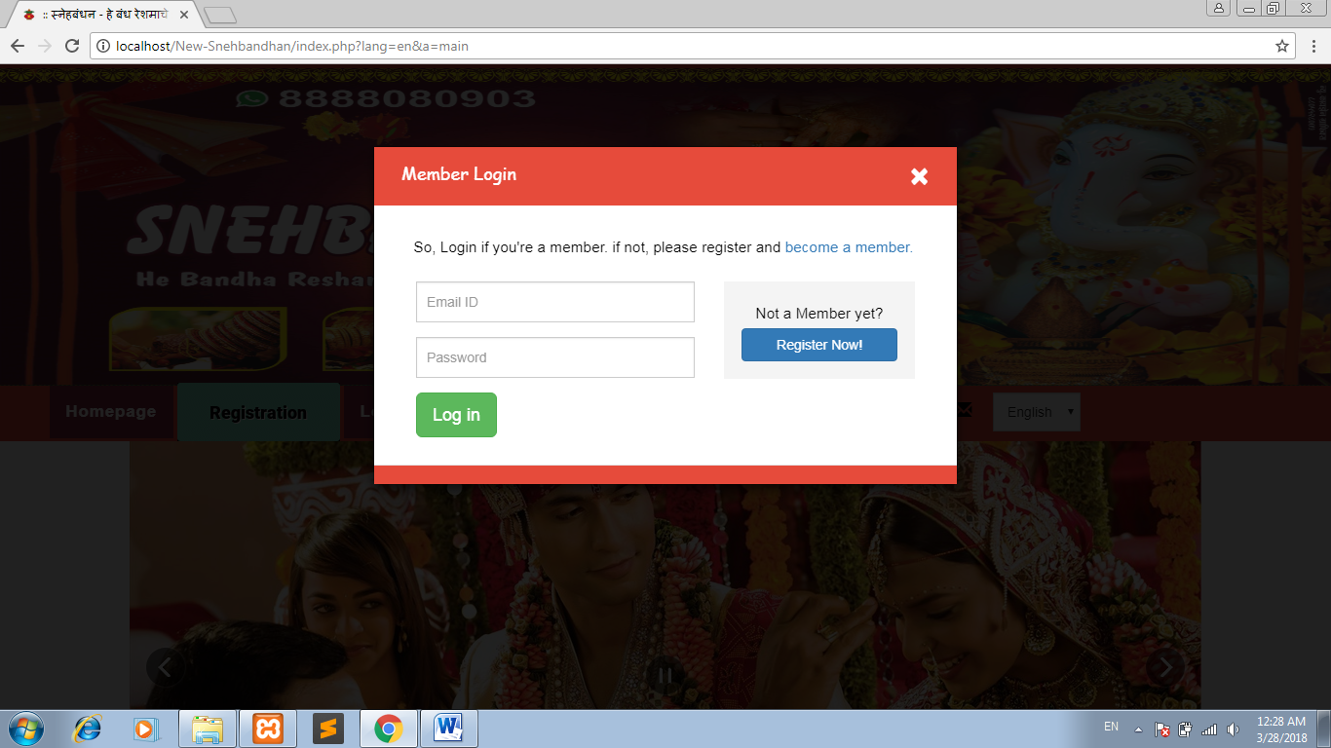

Suggestion

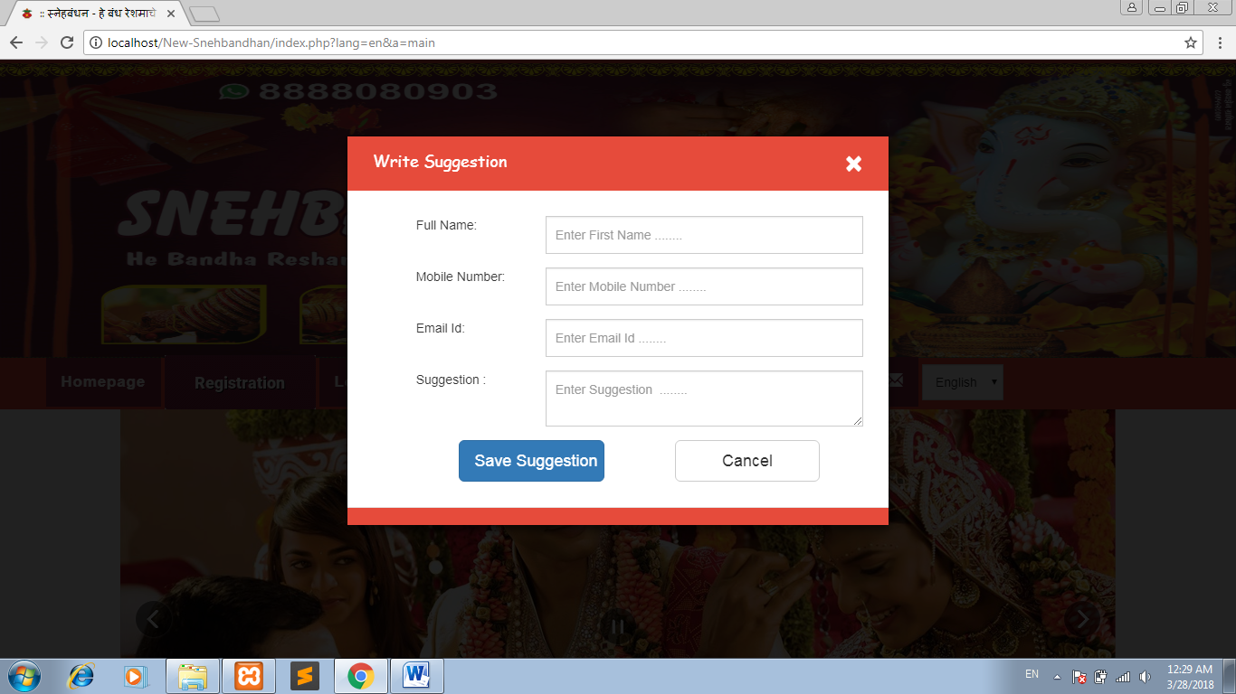

Registration

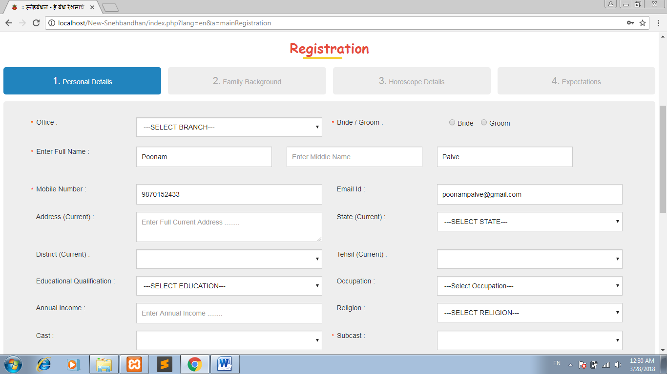

Search Profiles

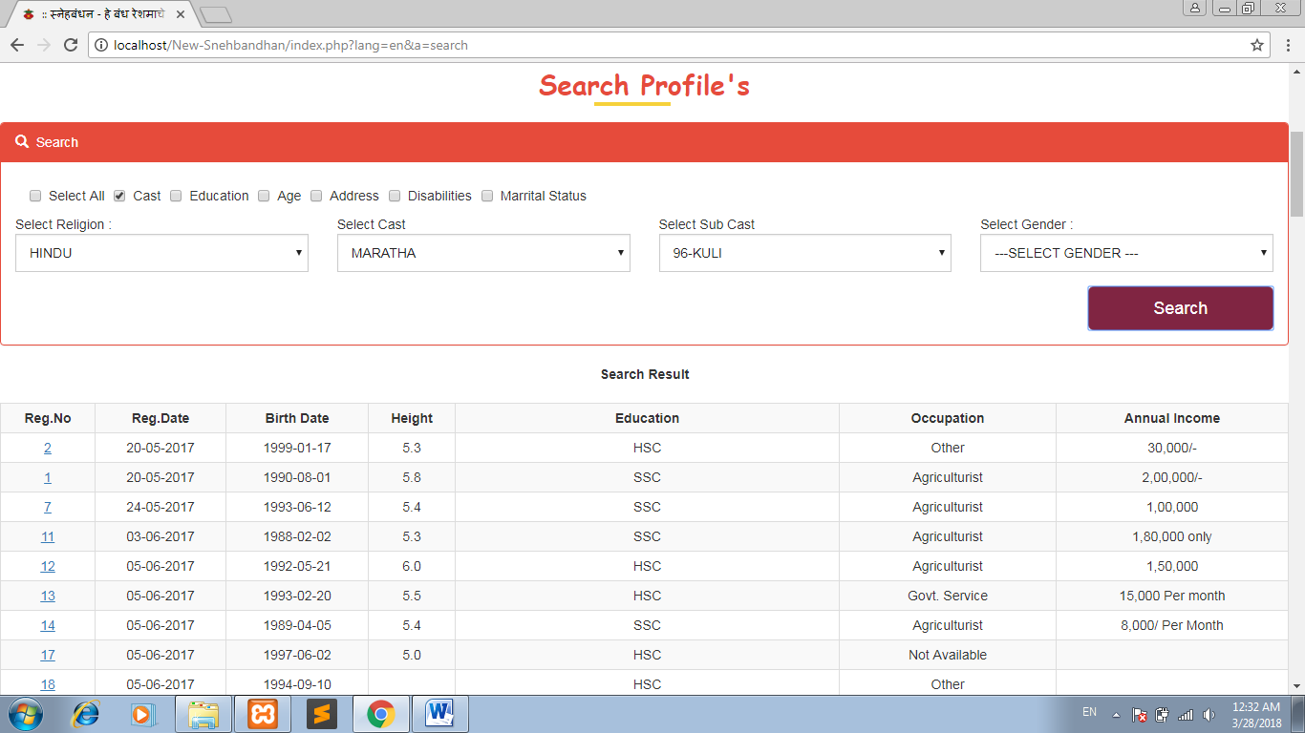

Admin Dashboard :

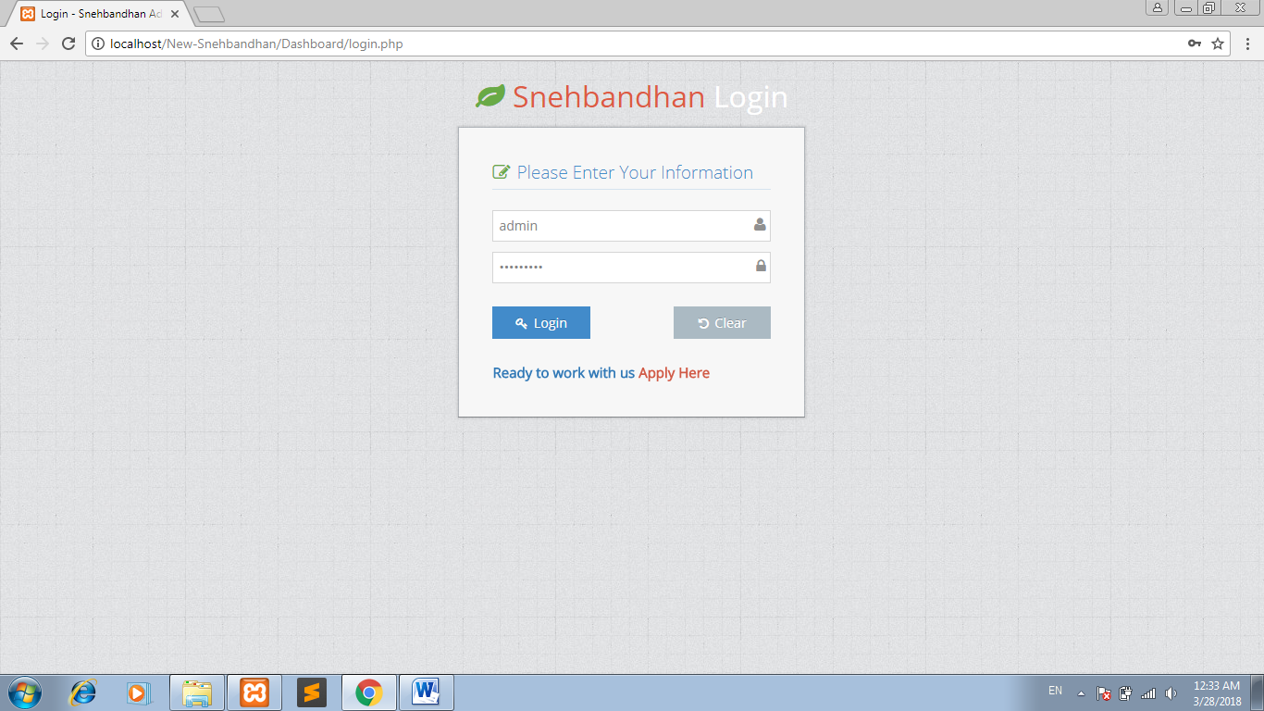

Dashboard :

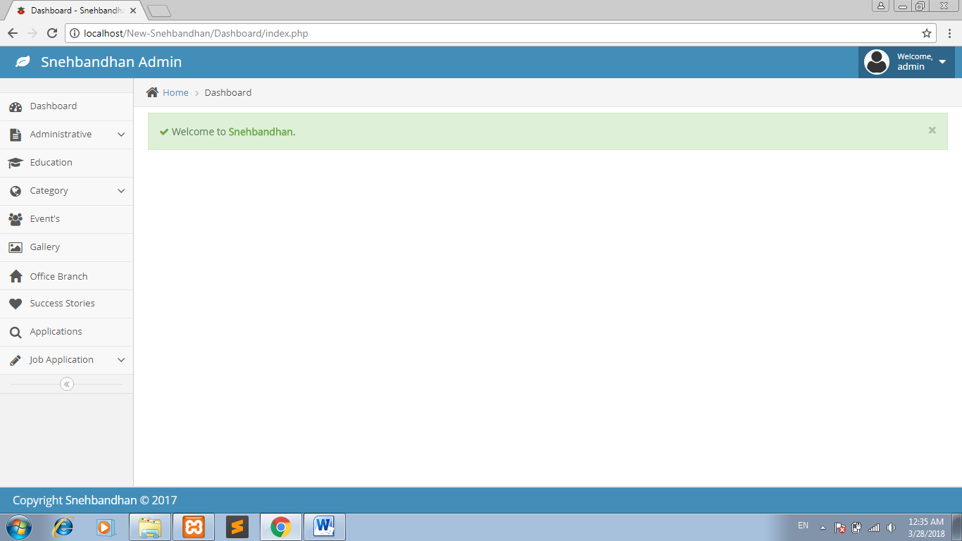

State

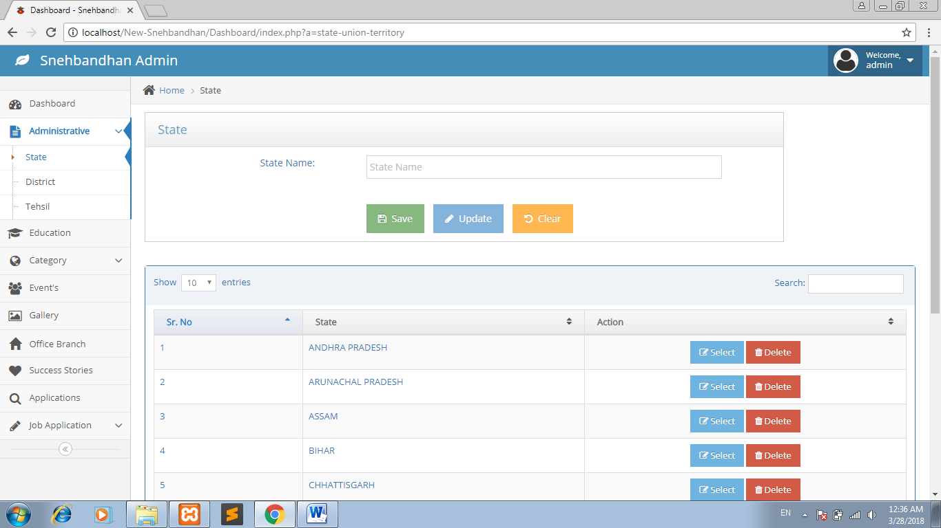

District

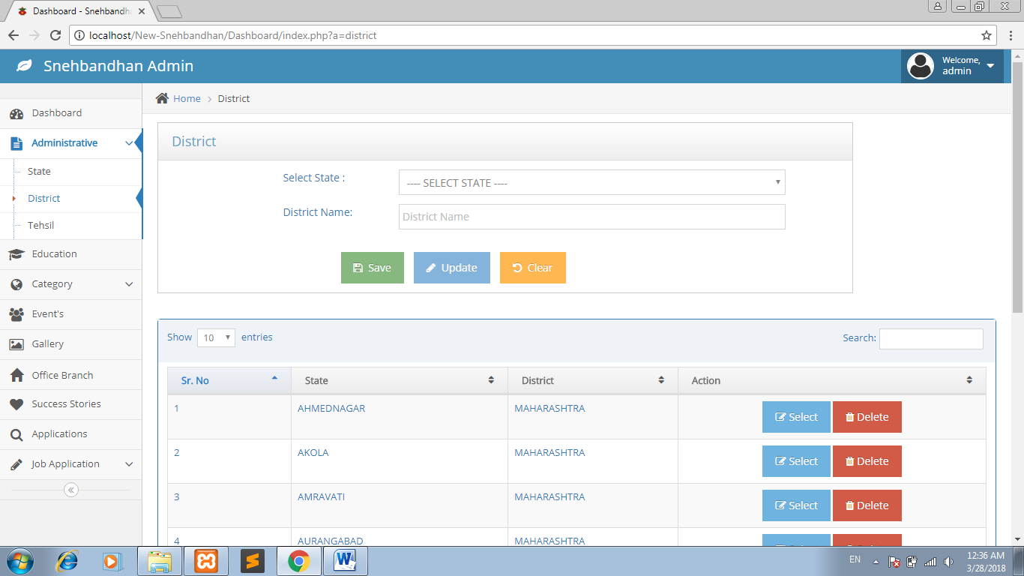

Tehsil

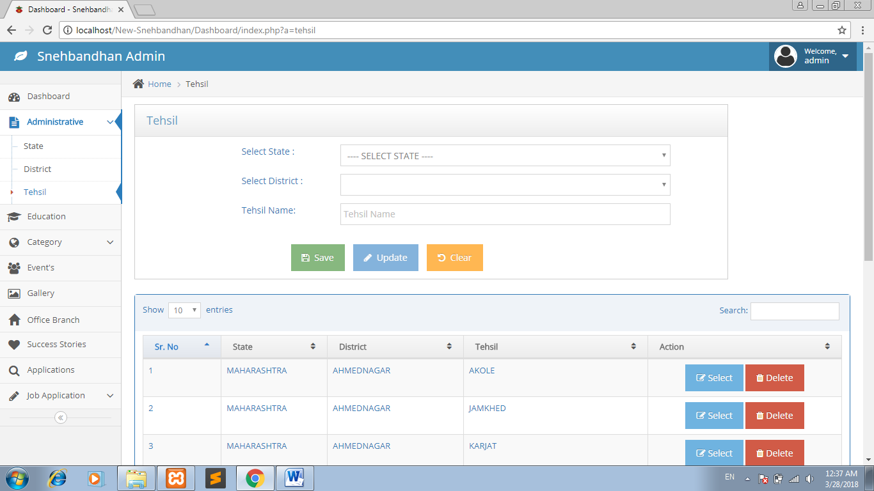

Education

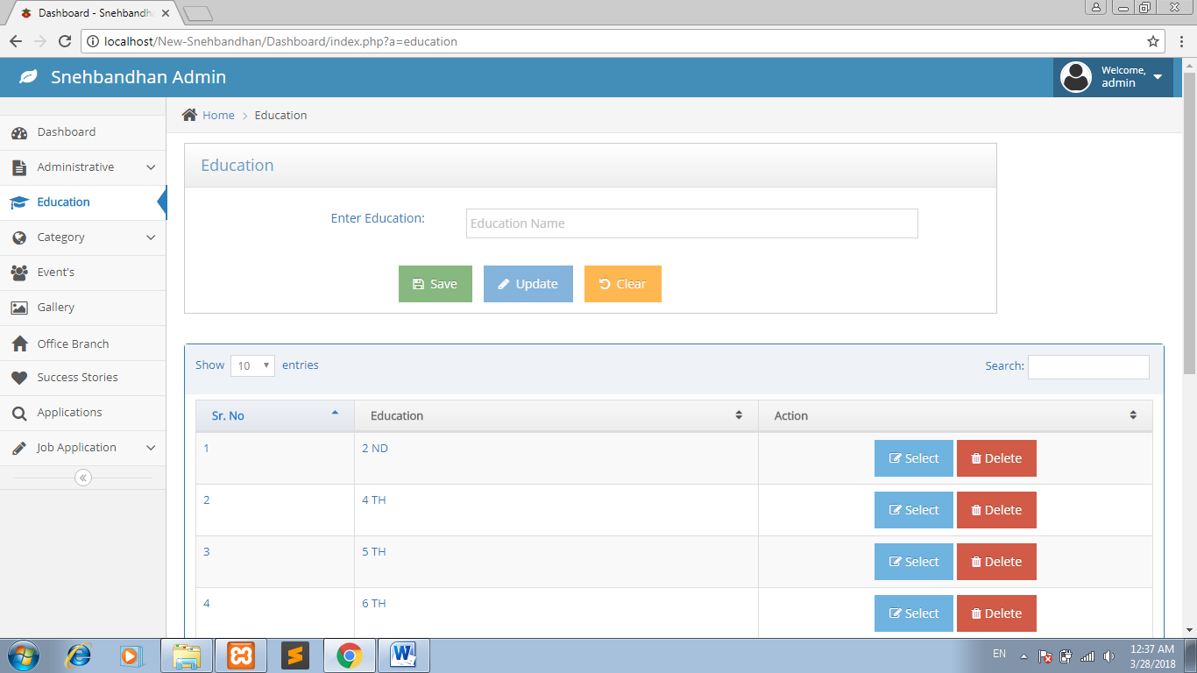

Religion

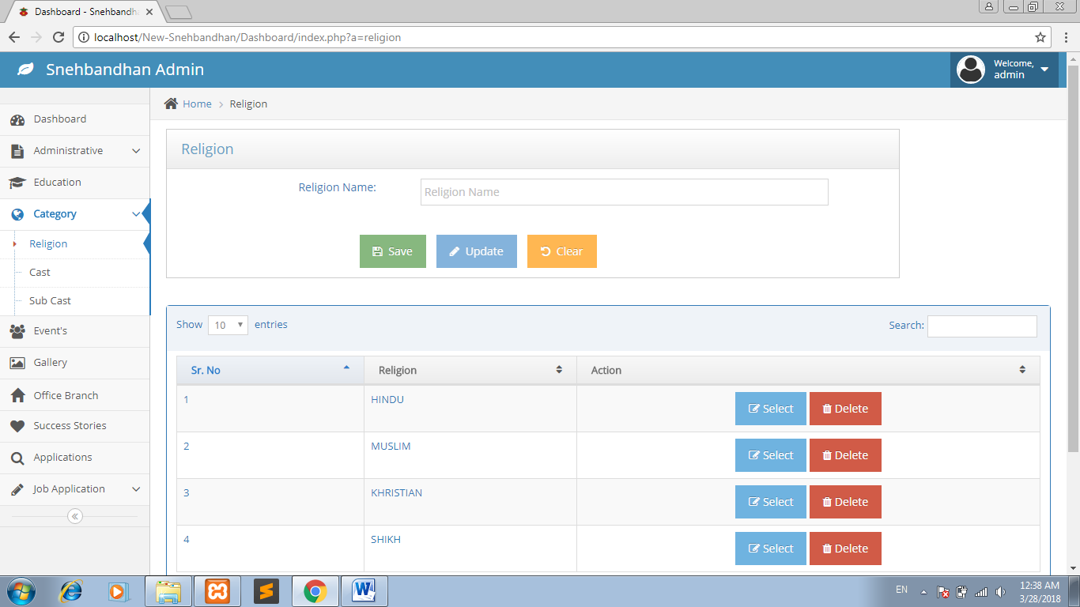

Cast

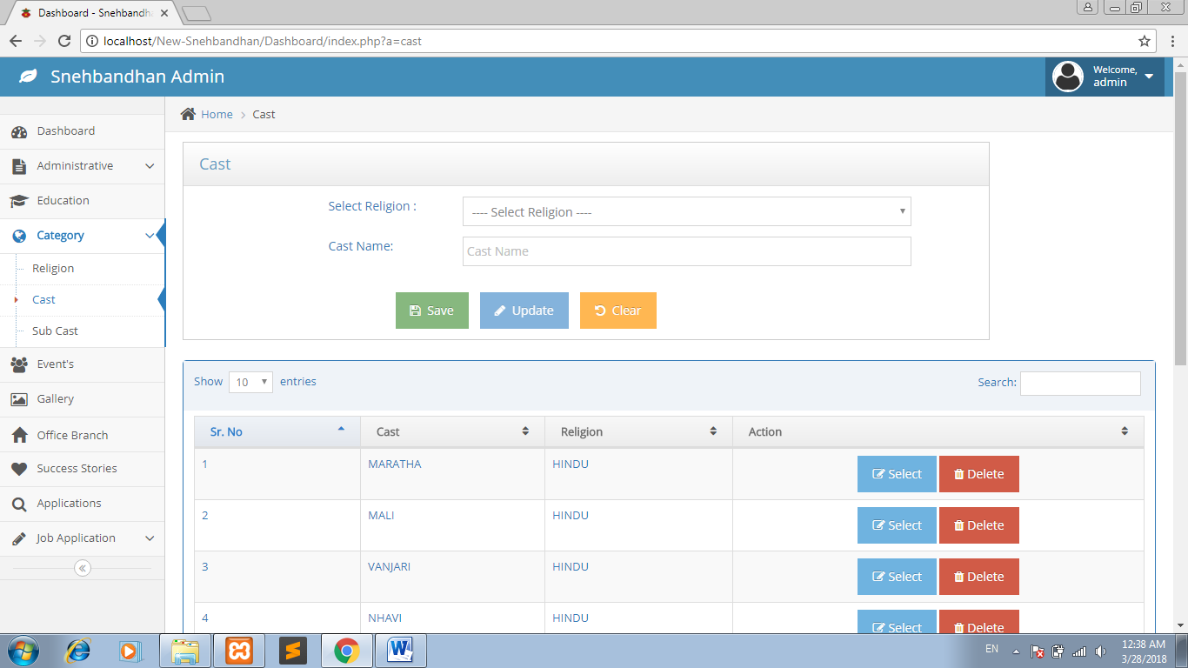

Subcast

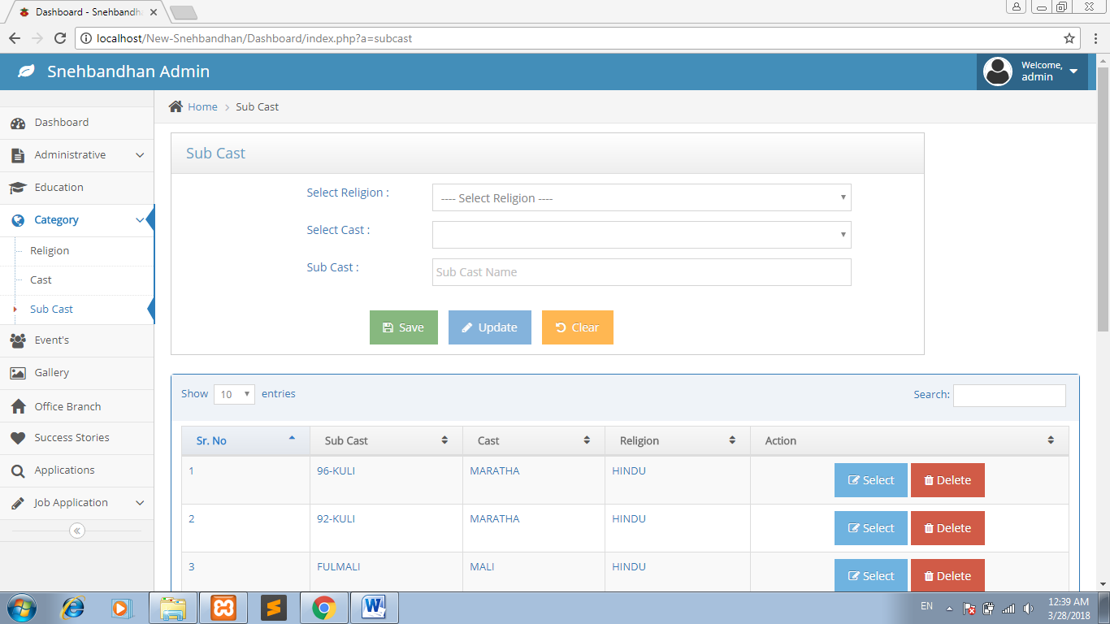

Events

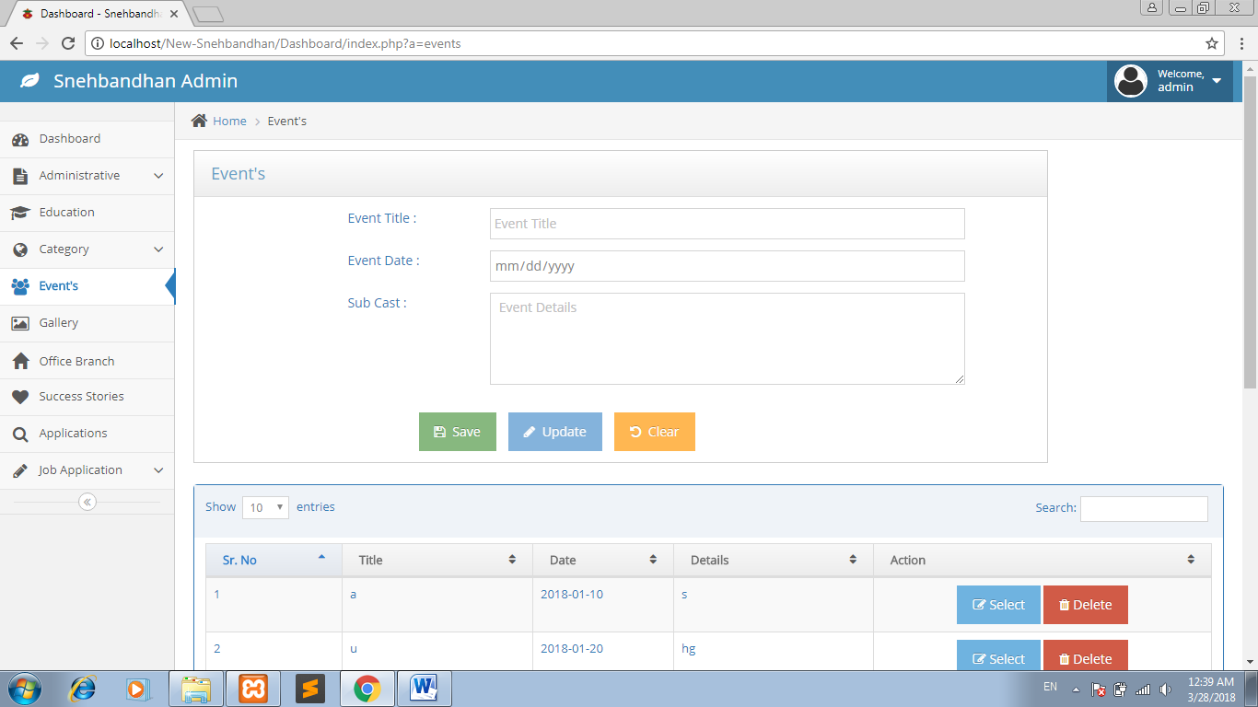

Gallery

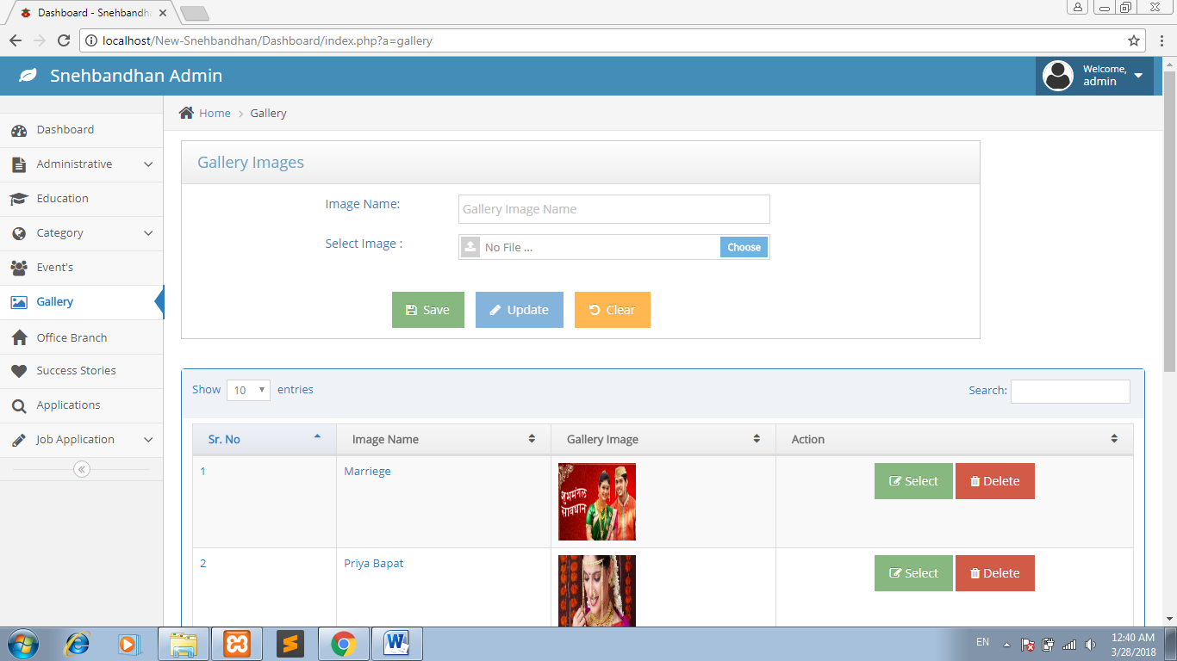

Office Branch

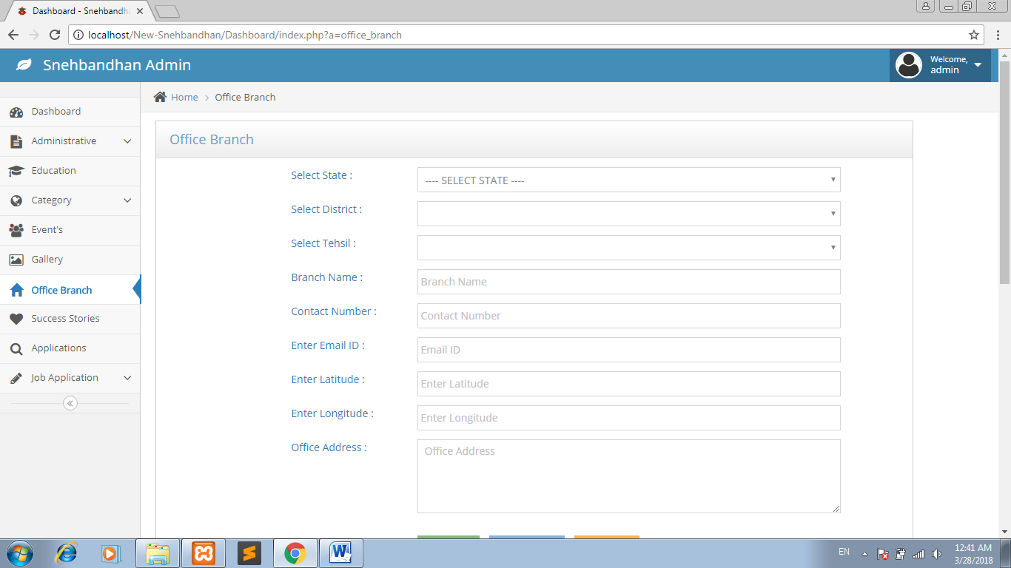

Success Stories :

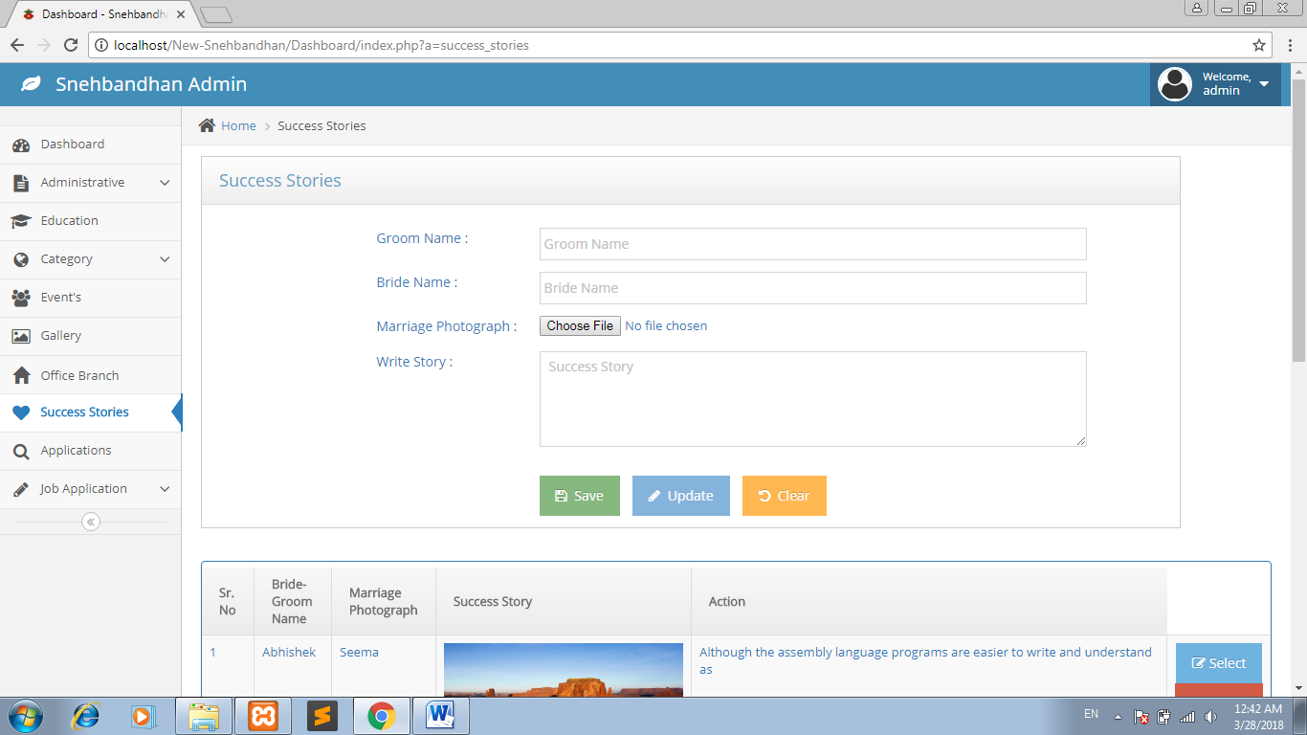

Applications:

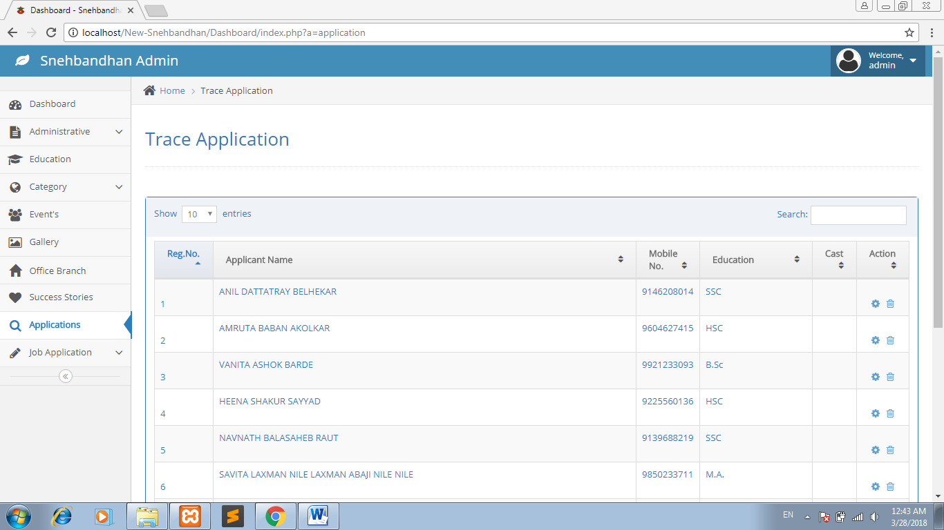

Application Delete :

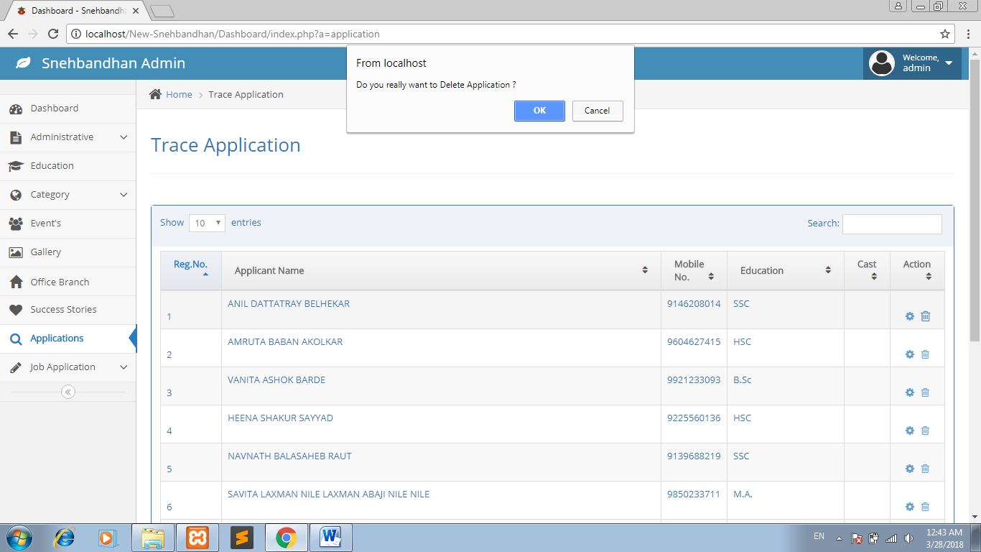

Change Password :

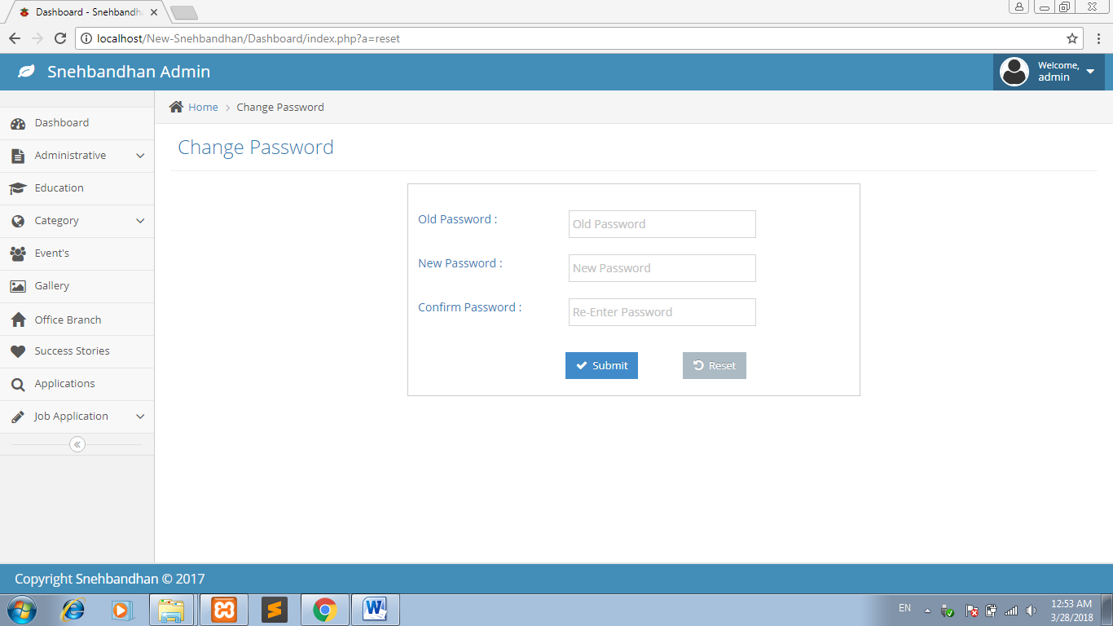

**3.11 Test Procedure and Implementation**

Any software application being developed incorporates sequential steps of production activities where there is a high chance of creeping in of an error in the data by human. Errors me start getting in the application at very early time of process during requirements investigation phase i.e. when the objectives of the system are being defined. Error may even drastically evolve at some later phase of the System Development Life cycle. But it is important to mention that errors that come in early stages if go undetected till a very later stage can be expensive in all terms. Hence, software development must be done taking into consideration its development along with Quality assurance activity.

The objective of testing is as follows:

* System test on functionality.
* Software is of high quality and replace existing environment.

It will be portable, reliable and easy to maintain.

* The software delivered interfaces correctly with existing system.

To assure the quality, it is highly necessary that the software being developed must have ample review of the product and the related documentation. It should ensure correctness, reliability, usability, integrity, efficiency, in regard to its operations; it should also ensure to portability, reusability, and interoperability in concern to the transition of the product and lastly, it must also conform to the specifications of maintainability, flexibility, testability in tune with the product’s revision. It also includes assurance that the system meets the specification and the requirement for the intended usage and performance.

Quality assurance can be confirmed by:

* Testing
* Verification & Validation

**TESTING:** Testing presents an interesting anomaly for the software engineer. The engineer creates a series of test cases that are intended to ‘demolish’ the software that has been built. In fact, testing is the one step in the software engineering process that could be viewed as destructive rather than constructive (through actually this is also a constructive step).

All testing activities were carried out keeping in mind the following things:

a) All tests should be traceable to customer requirements.

b) Test should be planned before testing commences

c) Initially testing should begin in small and gradually it should grow in shape

d) Testing is not done by the developer

Following testing methodologies are adopted in specified sequence

As the system belongs to the waterfall model of system design, the following testing approaches were used for this project:

**A. White Box Testing:**

White box testing approach was used to test the logic or code written and also to check that the system is functioning according to the user specifications.

Using this approach, every statement of the project was executed and tested for bugs. All the conditions present in the code were checked and all the loops were executed to see that they do not cross the operational boundaries.

White box testing was useful in finding logical errors in the code such as variables that were not declared, wrong execution of different types of loops and incorrect conditions.

**B. Black Box Testing:**

The end users at the firm were not concerned with the code of the system. But concerned with inputs and outputs that the system accepted and generated.

Using this approach of testing, it was useful in finding out interface errors. The users tested for boundary values of variables and conditions. The user also conducted random testing on the date and checked every GUI form for errors. Once they were satisfied only then they moved to then next form.

**C: Unit Testing:**

Unit testing was done at each stage of project development. After completion of every GUI form, it was tested using white box method of testing. This ensured that the form would integrate well with overall system.

**D: Integration Testing:**

Integration testing approach was also used to test between the different stages of the project. For e.g. it was checked to see whether information regarding items and payments are integrated with each other.

**Implementation Procedure:**

It has been decided to implement the system using the pilot approach of the installation. Using this approach the system would be tested against the old system for a few days and then when the users are completely satisfied with the new system, the old system will be replaced with the new system.

**Test Case Name:-Valid Login**

**Data Matrix**

|  |  |  |  |  |
| --- | --- | --- | --- | --- |
| **Input Attribute** | **ECP**  **Valid Invalid** | | **BVA**  **Min Max** | |
| User Name | A-Z,a-z,0-9 | Special Char | 2 | 10 |
| Password | A-Z,a-z,0-9,special character | Space, Tab | 4 | 10 |

**Test Procedures**

|  |  |  |  |
| --- | --- | --- | --- |
| **Sr No** | **Action** | **Input Required** | **Expected Output** |
| 1 | Enter user name & password | Correct User Type, user name & password | Enable to access system |

Test Case name Login:

|  |  |
| --- | --- |
| Test Case id | LOGIN_2 |
| Test Case Name | Test case for Login |
| Pre Requisites | Application Running & irrespective of the page |

|  |  |  |  |  |  |  |
| --- | --- | --- | --- | --- | --- | --- |
| Step No | Step to be executed | Expected Result | Actual result | Pass / fail | Remark | Defect id |
| 1 | Enter invalid username and password | Invalid username and password should be displayed | Page is redirected to same page | Pass | Invalid username and password are checked | Nil |
| 2 | Enter valid username and password | Page re-directed to respective home page(user/admin) | Page re-directed to respective home page(user/admin) | Pass | Invalid username and password are checked | Nil |

|  |  |  |  |  |  |  |  |
| --- | --- | --- | --- | --- | --- | --- | --- |
| Test Case id | | | | Email Validate | | | |
| Test Case Name | | | | Test case for email | | | |
| Step No | Step to be executed | Expected Result | Actual result | | Pass / fail | Remark | Defect id | |
| 1 | Enter invalid email without  ‘@’or’.’ | Invalid email Message should be displayed | Invalid email Message is displayed | | Pass | Invalid email is checked | Nil | |
| 2 | Enter valid email | System Should accept and proceed | Enter email gets displayed in textbox | | Pass | Valid email is checked | Nil | |

Test case id : Character validate

Test Case name: Character input

|  |  |  |  |  |  |  |
| --- | --- | --- | --- | --- | --- | --- |
| Step No | Step to be executed | Expected Result | Actual result | Pass / fail | Remark | Defect id |
| 1 | Enter Numeric value in text box | Invalid Character Error Message should be displayed | Invalid Character Error Message is displayed | Pass | Invalid Entries are checked | Nil |
| 2 | Enter Special character | Invalid Character Error Message should be displayed | Invalid Character Error Message is displayed | Pass | Invalid Entries are checked | Nil |
| 3 | Enter characters | System Should accept and proceed | Valid Character is entered and cursor transferred to next field | Pass | Characters are checked | Nil |

Teat case id: Number validate

Test case name: Number checking

|  |  |  |  |  |  |  |
| --- | --- | --- | --- | --- | --- | --- |
| Step No | Step to be executed | Expected Result | Actual result | Pass / fail | Remark | Defect id |
| 1 | Enter Special character or Alphabets | Invalid Character Error Message should be displayed | Invalid Character Error Message is displayed | Pass | Invalid Entries are checked | Nil |
| 2 | Enter Numeric value in text box | System Should accept and proceed | Valid Character is entered and cursor transferred to next field | Pass | Valid Entries are checked | Nil |

**Chapter 4**

**User Manual**

**4.1 USER MANUAL:**

User manual provide information , which help the user in operating the system . With the help of proper user manual user can operate the system easily . This user manual contains all the needed information about the system .

User of this system are :

1. Admin
2. User

However , this user manual specifically deals with the admin and users are guided by admin.

Users may also get the guidelines instructions from the help of section provided by this site.

.

**Chapter 5**

**Drawbacks and Limitation**

**Drawbacks**

Major efforts have been taken to complete this system but still it has some drawbacks which are not overcome yet.

* Help and facility information about the system would be insufficient .

**Limitations:**

This system has following limitations

* The backend technology if changed at some alter time may consume much time to get implemented.
* The users of the system can not communicate online to each other.

**Chapter 6**

**Proposed Enhancement**

**Proposed Enhancements:**

* Matrimonial website provide platform to a lot of Bride/Groom for finding perfect match.
* There are different sectors like Registration, Partner, Search, etc. So the Bride/Groom can get their interest for find their partner. Bride/Groom can directly search Partner according to their required criteria.
* The Bride/Groom can use match By Email functionality so he/she can get directly Email alert for the match which fulfill their required criteria.

**Chapter 7**

**Conclusion**

**Conclusion:**

Secured Online Matrimonial System provides Grooms and Brides with excellent matchmaking experience by exploring the opportunities and resources to meet true to potential partner. It secures information provided by user using standard encryption algorithms such as Advanced Encryption Standard (AES). It provides a Recommendation through Apriori algorithm. In short our system is best as compare to existing system because it provide higher security by using AES algorithm and fast searching through Apriori algorithm.

* User can find perfect matches.
* Visitor can view the site.
* User can view the information and give the feedback.

**Chapter 7**

**Biblography**

**Books:**

1. HTML- A Beginner's Guide, 4th Edition
2. Beginning HTML, XHTML, CSS, and JavaScript
3. Programming PHP, 3rd Edition
4. Beginning PHP 5.3

**Websites:**

1. [www.stackoverflow.com](http://www.stackoverflow.com)
2. www.w3cSchool.com